**Assignment 5- Practising Services**

Time to practice the usage of Services. You're going to build, inject and use your own Services. Make sure you get the instance management right!

The snapshot explains the example app you're starting with and which tasks should be completed as part of this assignment.

Make sure to also answer why you implemented the solution you chose to use.

**Problem Statement**: Here, we have got a couple of Active and Inactive Users. We can switch them from Active to Inactive and the other way around by clicking these buttons.

We would want you to add users services which manages these users arrays globally and where we call methods to switch users between to and fro. We then also want you to add a counter service which basically counts how often we do these two operations – Switch users from active to inactive and the other way around. Simply output that count when average increases.

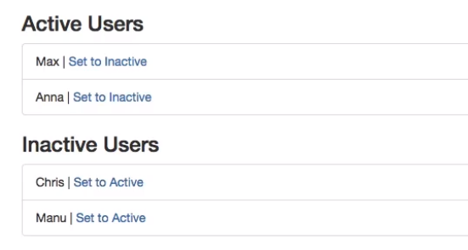

**Questions for this assignment**

**Please complete the tasks outlined in the instructions video. Why did you choose the approach you took? Which problems did you encounter?**

**Download resource files**

* services-assignment-start.zip